|  |  |
| --- | --- |
| Semester | T.E. Semester V – Computer Engineering |
| Subject | Computer Network |
| Subject Professor In-charge | Prof. Amit K. Nerurkar |
| Assisting Teachers | Prof. Amit K. Nerurkar |
| Laboratory | M-313-A |

|  |  |
| --- | --- |
| Student Name | Deep Salunkhe |
| Roll Number | 21102A0014 |
| TE Division | A |

**Title : Hamming Code**

**Theory:**

Hamming codes are designed to detect and correct single-bit errors. The receiver checks the received code word for errors using the parity bits. If an error is detected, the receiver can pinpoint the erroneous bit and correct it. If multiple errors occur, Hamming codes may not be able to correct them.

**Implementation**:

#include<iostream>

#include<cmath>

#include<vector>

#include<cstdlib>

#include<ctime>

using namespace std;

*// Function to find the number of redundant bits required (r)*

void findr(int &r)

{

    for (int i = 0; i < 7; i++)

    {

        if (pow(2, i) >= 7 + i + 1)

        {

            r = i;

            break;

        }

    }

}

*// Function to calculate the parity bits (R1, R2, R4, R8)*

void fparity(int &R1, int &R2, int &R4, int &R8, vector<int> frame)

{

*// R1 family*

    int p1 = 0;

    for (int i = 0; i <= 11; i = i + 2)

    {

        if (frame[i] == 1)

            p1++;

    }

    R1 = 1;

    if (p1 % 2 == 0)

        R1 = 0;

*// R2 Family*

    int p2 = 0;

    if (frame[9] == 1)

        p2++;

    if (frame[8] == 1)

        p2++;

    if (frame[5] == 1)

        p2++;

    if (frame[4] == 1)

        p2++;

    if (frame[1] == 1)

        p2++;

    if (frame[0] == 1)

        p2++;

    R2 = 1;

    if (p2 % 2 == 0)

        R2 = 0;

*// R4 family*

    int p4 = 0;

    for (int i = 4; i <= 7; i++)

    {

        if (frame[i] == 1)

            p4++;

    }

    R4 = 1;

    if (p4 % 2 == 0)

        R4 = 0;

*// R8 family*

    int p8 = 0;

    for (int i = 0; i <= 3; i++)

    {

        if (frame[i] == 1)

            p8++;

    }

    R8 = 1;

    if (p8 % 2 == 0)

        R8 = 0;

    cout << "R1 R2 R4 R8" << endl;

    cout << R8 << " " << R4 << " " << R2 << " " << R1 << endl;

}

*// Function to display received data without errors*

void Noerror(vector<int> frame)

{

    cout << "Received Data: ";

    for (int i = 0; i < frame.size(); i++)

    {

        cout << frame[i] << " ";

    }

    cout << "\nData is error-free (OK)" << endl;

    int R1, R2, R4, R8;

    fparity(R1, R2, R4, R8, frame);

    frame[10] = R1; *//R1*

    frame[9] = R2; *//R2*

    frame[7] = R4; *//R4*

    frame[3] = R8; *//R8*

*//parity bits*

    cout << "As all the parities are 0" << endl;

}

*// Function to simulate received data with errors*

void Witherror(vector<int> frame)

{

    vector<int> itf = {0, 1, 2, 4, 5, 6, 8};

    int randn = rand() % 7;

    if (frame[itf[randn]] == 1)

        frame[itf[randn]] = 0;

    else

        frame[itf[randn]] = 1;

    cout << "Received Data with Errors: ";

    cout<< frame.size()<<endl;

    for (int i = 0; i < frame.size(); i++)

    {

        cout << frame[i] << " ";

    }

    cout<<endl;

    int R1, R2, R4, R8;

    fparity(R1, R2, R4, R8, frame);

    frame[10] = R1; *//R1*

    frame[9] = R2; *//R2*

    frame[7] = R4; *//R4*

    frame[3] = R8; *//R8*

*// Finding and displaying the error position*

    int error = 0;

    if (R8 == 1)

        error += 8;

    if (R4 == 1)

        error += 4;

    if (R2 == 1)

        error += 2;

    if (R1 == 1)

        error += 1;

    cout << "Error at bit position " << error <<"th bit  from end in frame "<< endl;

}

*// Function to send the data*

void sender(vector<int> &data, int &r)

{

    cout << "Enter 7-bit data: ";

    for (int i = 0; i < 7; i++)

        cin >> data[i];

    findr(r);

    int fsize = 7 + r; *// m + r*

    vector<int> frame(fsize, 0);

*// Initialize parity bits to -1*

    frame[10] = -1; *//R1*

    frame[9] = -1; *//R2*

    frame[7] = -1; *//R4*

    frame[3] = -1; *//R8*

*// Fill the frame with data*

    int id = 0; *// Trace the data*

    for (int i = 0; i < fsize; i++)

    {

        if (frame[i] == -1)

            continue;

        frame[i] = data[id];

        id++;

    }

*// Calculate and set the parity bits*

    int R1, R2, R4, R8;

    fparity(R1, R2, R4, R8, frame);

    frame[10] = R1; *//R1*

    frame[9] = R2; *//R2*

    frame[7] = R4; *//R4*

    frame[3] = R8; *//R8*

    cout << "Sending Data to user...." << endl;

    cout << "Sent Data: ";

    for (int i = 0; i < fsize; i++)

    {

        cout << frame[i] << " ";

    }

while(1)

{

    cout << "\nChoose an option:\n";

cout << "1. Send without error\n";

cout << "2. Send with error\n";

cout << "Enter your choice: ";

    int choice;

  cin >> choice;

    switch (choice) {

    case 1:

        Noerror(frame);

        break;

    case 2:

        Witherror(frame);

        break;

    default:

        cout << "Invalid choice." << endl;

        break;

}

}

}

int main()

{

    srand(time(0)); *// Seed the random number generator*

    vector<int> data(7);

    int r; *// Number of redundant bits*

    sender(data, r);

    return 0;

}

**Output:**

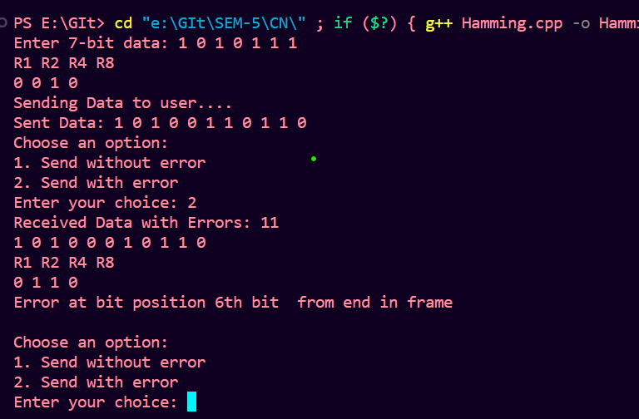

Top of Form